Chapter 11 Acids and Bases name: class:
考点 A: 酸碱理论 Acid-Base Theories
Brønsted-Lowry acid: proton donor; Brønsted-Lowry base: proton acceptor
Conjugate acid-base pair: acid loses H⁺ → conjugate base; base gains H⁺ → conjugate acid
Amphoteric species can act as both acid and base (e.g. H₂O, HCO₃⁻, HPO₄²⁻)

1. H₂PO₄− (aq) + CN- (aq) ⇌ HCN (aq) + HPO₄₂− (aq) What is the conjugate acid in the reaction above? （ ）
A. Option A
B. Option B
C. Option C
D. Option D

2. H₃PO₄ (aq) + H₂O (l) ⇌ H₂PO₄- (aq) + H₃O+ (aq) Consider the reaction above.
Which of the following statements is true? （ ）
A. H₃PO₄ and H₂PO₄- is a base and conjugate acid pair.
B. H₂PO₄- is a weak base.
C. H₂O is acting as Brønsted-Lowry acid.
D. H₃O+ is the conjugate base of H₂O.

3. H₃NSO₃ (aq) + 2NH₃ (aq) ⇌ HNSO₃2- (aq) + 2NH₄+ (aq) For the equilibrium equation shown, which species are Brønsted-Lowry acids? （ ）
A. Equation A
B. Equation B
C. Equation C
D. Equation D

4. H₂SO₄ + HNO₃ ⇋ H₂NO₃+ + HSO₄- The reaction above occurs between concentrated sulfuric and nitric acids.
Identify the two species which are acting as Brønsted–Lowry bases. （ ）
A. Option A
B. Option B
C. Option C
D. Option D

5. H₂O (l) + F- (aq) ⇌ HF (aq) + OH- (aq) H₂O (l) + HNO₃ (aq) → H₃O+ (aq) + NO₃- (aq) H₂O (l) + CO₂ (g) ⇌ H₂CO₃ (aq) NH₃ (aq) + H₂O (l) ⇌ NH₄+ (aq) + OH- (aq) Consider the reactions above.
Which of the following statements is true? （ ）
A. H₂O is shown acting as a Bronsted-Lowry acid only.
B. NO₃- is a strong base.
C. H₂O acts as a Bronsted-Lowry acid twice.
D. F- is the conjugate acid of HF.

6. Potassium hydrogenphosphate has the formula K₂HPO₄ . What is the conjugate base of this compound? （ ）
A. Equation A
B. Equation B
C. Equation C
D. Equation D

7. Which of the following is the conjugate base of carbonic acid (H₂CO₃)? （ ）
A. Option A
B. Option B
C. Option C
D. Option D

8. HBrO (aq) + H₂O (l) ⇌ BrO- (aq) + H₃O+ (aq) Which one of the following statements is true about the reaction above? （ ）
A. HBrO is the conjugate base of BrO-
B. H₃O+ is the conjugate acid of H₂O
C. BrO- is the conjugate acid of HBrO
D. There are no conjugate acid-base pairs in the equilibrium

9. Phenol (C₆H₅OH) is an aromatic compound with a hydroxyl group attached to a benzene ring.
It behaves as a weak acid by donating a proton to form a conjugate base.
What is the correct formula of the conjugate base of phenol? （ ）
A. Option A
B. Option B
C. Option C
D. Option D

10. Phosphoric acid (H₃PO₄​) is a polyprotic acid that can dissociate to form amphoteric species.
Which of the following species are amphoteric? （ ）
A. Option A
B. Option B
C. Option C
D. Option D

考点 B: pH pH Scale
pH = −log[H⁺]; pOH = −log[OH⁻]; pH + pOH = 14 (at 25°C)
Kw = [H⁺][OH⁻] = 1.0×10⁻¹⁴ at 25°C (autoionization of water)
Neutral solution: [H⁺] = [OH⁻]; at 25°C, pH = 7
As temperature increases, Kw increases, pH of pure water decreases (still neutral)

1. 25.00 mL of 0.25 M nitric acid is added to 12.50 mL of 0.10 M sodium hydroxide.
What is the pH of the resulting mixture? （ ）
A. Option A
B. Option B
C. Option C
D. Option D

2. Which of the following statements is correct? （ ）
A. As temperature increases, the pH value of pure water decreases
B. As temperature decreases, the pH value of pure water decreases
C. The pH of water is unaffected by temperature
D. Pure water is not neutral

3. What is the correct comparison of hydrogen ions between a solution of pH 2 and a solution of pH 4? （ ）
A. Option A
B. Option B
C. Option C
D. Option D

4. The pH of a sample of acid rain at 25 C is 4.55. What is the [OH-] in the sample? （ ）
A. Option A
B. Option B⁻¹⁰ M
C. Option C⁻⁵ M
D. Option D⁻¹⁴ M

5. What is the pH of a solution of NaOH of concentration 0.001 M? （ ）
A. Option A
B. Option B
C. Option C
D. Option D

6. Two flasks contain two different acids labelled as HA and HB. A student measures the pH of each flask, and finds that they are pH 1 and pH 3 respectively.
Which of the following statements is true? （ ）
A. HA is a stronger acid than HB
B. HB is a stronger acid than HA
C. The [H₃O+] in the solution of HB is 3 times greater than the [H₃O+] in the solution of HA.
D. The [H₃O+] in the solution of HA is 100 times greater than the [H₃O+] in the solution of HB.

7. When 300 mL of 1.5 M KOH (aq) is added to 400 mL of 0.8 M HBr (aq), the pH of the resulting mixture is closest to （ ）
A. Option A
B. Option B
C. Option C
D. Option D

8. AcidConcentration (M)pH X0.0102.1Y1.53.0Z2.53.5 Which of the following correctly ranks the three monoprotic acids listed in the table above from the strongest to the weakest? （ ）
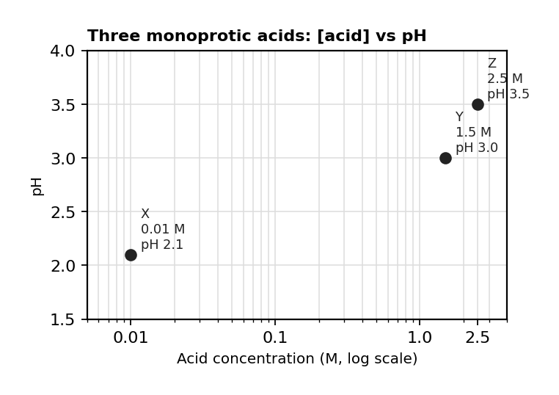
图 C₁1-2：三种一元酸的浓度与 pH 关系（对应考点 B MCQ8）
A. Option A
B. Option B
C. Option C
D. Option D

考点 C: 弱酸弱碱 Weak Acids and Bases
1. 掌握弱酸 pH 和 Ka 的计算
Weak acid: HA ⇌ H⁺ + A⁻, Ka = [H⁺][A⁻]/[HA]
For weak acid: [H⁺] ≈ √(Ka × c) if percent ionization < 5%
pH = −log[H⁺]; pKa = −logKa

1. CH₃COOH (Ka=1.8×10⁻⁵, 0.100 M). pH ≈ ? （ ）
A 1.00
B 2.87
C 4.74
D 5.00

1. HCOOH (formic acid, Ka=1.8×10⁻⁴, 0.0500 M).
(a) Write the ionization equation and Ka expression. [1 mark]
(b) Calculate the pH. [2 marks]
(c) Calculate percent ionization. [1 mark]

3. 掌握盐的水解和酸碱强度比较
Salt of strong acid + strong base → neutral; weak acid + strong base → basic; strong acid + weak base → acidic
Acid strength increases with: more electronegative central atom; more oxygen atoms; more stable conjugate base

2. An aqueous solution of NH₄Cl is: （ ）
A acidic (NH₄⁺ is conjugate acid of weak base).
B basic (Cl⁻ is conjugate base of weak acid).
C neutral.
D cannot be determined.

3. Which is the strongest acid? （ ）
A HClO (Ka=2.9×10⁻⁸)
B HCOOH (Ka=1.8×10⁻⁴)
C HNO₂ (Ka=5.6×10⁻⁴)
D HClO₄ (strong acid)

4. The pKb value of HPO₄2- is 6.8. What is its conjugate acid and what is the Ka value? （ ）
A. Option A
B. Option B
C. Option C⁻⁷
D. Option D⁻⁸

5. Which of the following salts would produce a solution with the highest pH if dissolved in water? （ ）
A. Option A
B. Option B
C. Option C
D. Option D

6. The table below shows data for the and values for some acids and bases at 298 K.
AcidKaBasepKbC₅H₆OH1.02 x10-10(C₂H₅)3N3.25O₂NC₆H₄OH7.08 x10-8C₆H₅NH₂9.13 Which two formulas represent the weakest acid and the weakest base in the table? （ ）
A. Option A
B. O₂NC₆H₄OH and C₆H₅NH₂
C. O₂NC₆H₄OH and (C₂H₅)3N
D. Option D

7. Which of the following is the acid dissociation, Ka, constant for ethanoic acid? （ ）
A. Option A
B. Option B
C. Option C
D. Option D

8. What is the correct expression for the base dissociation constant, Kb, for propylamine? （ ）
A. Equation A
B. Equation B
C. Equation C
D. Equation D

9. HF (aq) ⇌ H+ (aq) + F (aq) Ka = 6.3 x10⁻⁴ On the basis of the information above, what is the approximate percent ionization of HF in a 0.25 M HF (aq) solution? （ ）
A. Option A
B. Option B
C. Option C
D. Option D⁻⁴%

10. What is the approximate pH of 0.50 M benzoic acid, C₆H₅COOH (aq)? Ka of C₆H₅COOH = 6.3 x10⁻⁵ （ ）
A. Option A
B. Option B
C. Option C
D. Option D

11. The Kb value for a base is 8.0 x10-4 at 298 K.
What is the pKa value for the conjugate acid at this temperature? （ ）
A. Option A
B. Option B⁻¹¹
C. Option C
D. Option D

考点 D: 酸碱滴定 Titration
2. 掌握滴定曲线和缓冲溶液
Titration: weak acid + strong base → equivalence pH > 7 (due to conjugate base hydrolysis)
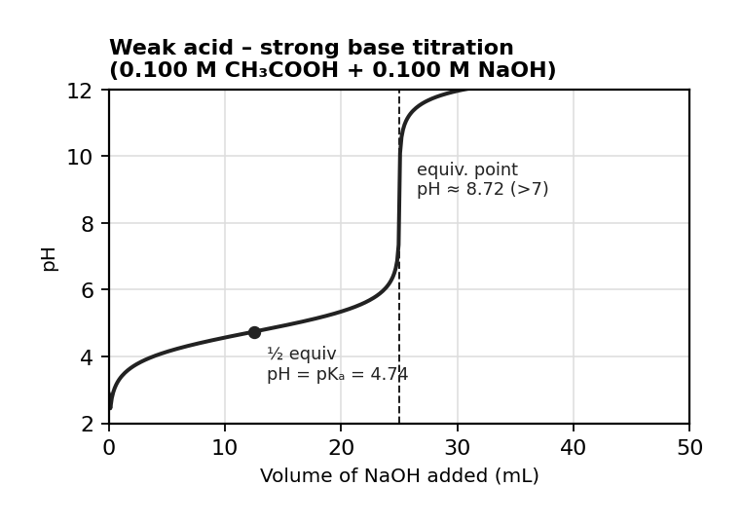
图 C₁1-1：弱酸-强碱滴定曲线（对应考点 D，半等当点 pH=pKa）
Half-equivalence point: [HA] = [A⁻], pH = pKa

1. 25.0 mL of 0.100 M CH₃COOH titrated with 0.100 M NaOH (Ka=1.8×10⁻⁵). （ ）
(a) What is the pH at the half-equivalence point? [1 mark]
(b) Calculate the pH at the equivalence point. [3 marks]

1. Which type of titration is indicated by the pH curve above? （ ）
A. Strong acid - strong base
B. Weak acid - weak base
C. Strong acid - weak base
D. Weak acid - strong base

2. The table below shows the pKa values of four acid-base indicators:
IndicatorpKaMethyl orange3.7Phenolphthalein9.6Phenol red7.9Bromothymol blue7.0 Which indicator would be most appropriate for a titration between hydrochloric acid and ammonia? （ ）
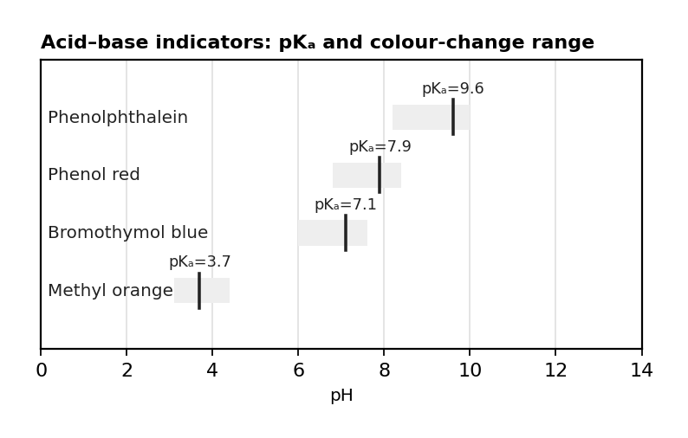
图 C₁1-3：酸碱指示剂 pKa 与变色范围（对应考点 D MCQ2）
A. Graph A
B. Graph B
C. Graph C
D. Graph D

3. A 0.10 mol dm-3 solution of propanoic acid is titrated with 0.10 mol dm-3 potassium hydroxide.
Which of the following statements accurately describes this titration （ ）
A. The equivalence point occurs at pH 7.
B. The salt formed hydrolyzes to form an acidic salt.
C. The salt formed at the equivalence point is CH₃COOK.
D. At the half-equivalence point, [CH₃CH₂COOH] = [CH₃CH₂COO-].

4. In a titration, the equivalence point is reached when 23.70 mL of 0.02 M potassium hydroxide reacts with 0.03 M of sulfuric acid.
What volume of acid is needed? （ ）
A. Option A
B. Option B
C. Option C
D. Option D

5. 5.
The acid–base indicator bromophenol blue changes colour from yellow to blue over a pH range of 3.0–4.6. The acid–base indicator bromophenol blue changes colour from yellow to blue over a pH range of 3.0–4.6.
Which statement(s) is/are correct? （ ） Which statement(s) is/are correct? （ ）
I. The pKa is between 3.0 and 4.6
II. In a neutral solution [HIn] > [In-]
III. It is a suitable indicator for a strong acid, weak base titration
A. Option A
B. Option B
C. Option C
D. Option D

6. The pH curve above represents a weak acid, strong base titration.
The pH of the acid at half equivalence point is 4.90.
What is the Ka of the acid? （ ）
A. Option A
B. Option B
C. Option C⁻⁵
D. Option D⁻⁹

7. A titration is carried out using 25.00 cm3 of 0.100 mol dm-3 propanoic acid and 0.100 mol dm-3 sodium hydroxide.
Phenolphthalein (pH range: 8.3 – 10.0) is used to determine the equivalence point.
If 0.100 mol dm-3 hydrochloric acid is used instead of propanoic acid, which of the following remains unchanged? （ ）
A. The volume of base required to reach the equivalence point.
B. The pH at the equivalence point.
C. The y-intercept of the pH curve.
D. The color of the solution just before equivalence is reached.

考点 E: 缓冲溶液 Buffer Solutions
Buffer: mixture of weak acid + conjugate base; pH = pKa + log([A⁻]/[HA]) (Henderson-Hasselbalch)
Buffer resists pH change when small amounts of acid or base are added

1. A buffer is made from 0.250 M CH₃COOH and 0.250 M CH₃COONa (pKa=4.74). The pH is: （ ）
A 4.74
B 4.44
C 5.04
D 7.00

1. A buffer is made from 0.100 M NH₃ and 0.100 M NH₄Cl. (Kb for NH₃ = 1.8×10⁻⁵)
(a) Calculate the pKa of NH₄⁺ and the pH of the buffer. [3 marks]
(b) 0.0050 mol HCl is added to 1.00 L. Calculate resulting pH. [2 marks]

2. Which mixture will not act as a buffer? （ ）
A. CH₃COOH (aq) and CH₃COONa (aq)
B. CH₃CH₂COOH (aq) and CH₃CH₂COONa (aq)
C. HNO₃ (aq) and NaOH (aq)
D. NH₃ (aq) and NH₄Cl (aq)

3. A buffer at pH 4.40 is prepared from a weak acid with a pKa = 4.60.
If 50 mL of this buffer is diluted to 100 mL with distilled water, what is the pH of the dilute solution? （ ）
A. Option A
B. Option B
C. Option C
D. Option D

4. Which statement about buffer solutions is not correct? （ ）
A. A buffer resists small changes in pH.
B. A buffer can be formed from sodium hydroxide and an excess of ethanoic acid.
C. The pH during a titration between a strong acid and weak base changes slowly in the buffer region.
D. When a strong acid is added to a buffer, hydrogen ions react with salt ions.

5. A buffer with a pH of 5.00 is needed. Which of the following should be used? （ ）
A. Ammonia with a Kb of 1.8 x10⁻⁵.
B. Ethanoic acid with a Ka of 1.8 x10⁻⁵.
C. Carbonic(II) acid with a Ka of 4.7 x10⁻¹¹.
D. Nitrous acid with a Ka of 4.0 x10⁻⁴.

6. Adding which of the following to a 50. mL sample of 0.10 M CH₃COOH (aq) (pKa = 4.76) would result in the formation of a buffer solution with a pH of 4.76? （ ）
A. 50 mL of 0.10 M NaOH (aq)
B. 25 mL of 0.10 M CH₃COONa (aq)
C. 50 mL of 0.10 M CH₃COONa (aq)
D. 25 mL of 0.10 M NaOH (aq)

7. The weak acid CH₃COOH has a pKa of 4.76. A solution is prepared by mixing 250 mL of 0.200 M CH₃COOH (aq) and 0.8 g of NaOH (s).
Which of the following can be used to calculate the pH of the solution? （ ）
A. pH = 4.76 + log10 = 4.93
B. pH = 4.76 + log10 = 6.36
C. pH = 4.76 + log10 = 4.58
D. pH = 4.76 + log10 = 4.36

8. AcidKa at 298 Kacetic acid 1.7 x10-5formic acid 1.8 x10-4 The correct solution to form a buffer with a pH of 4.77 is: （ ）
A. 0.10 M acetic acid 0.50 L with 0.10 M sodium hydroxide 0.25 L
B. 0.10 M acetic acid 0.50 L with 0.20 M sodium hydroxide 0.25 L
C. 0.10 M formic acid 0.50 L with 0.10 M sodium hydroxide 0.25 L
D. 0.10 M formic acid 0.50 L with 0.20 M sodium hydroxide 0.25 L

